Introduction to Computation Theory Quiz 3 — In-class (20 pts)

Answer all questions

1. ' [10 pts] The following are the state diagrams of two DFAs, Ml and M2. Answer the following questions about each of these machines:

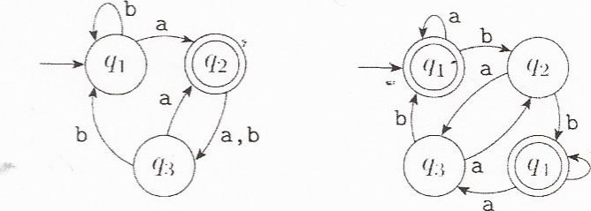b

Ali

a. [1 pts] What is the start state?

Ml -> Starts at ql

# M2 -> Starts at ql

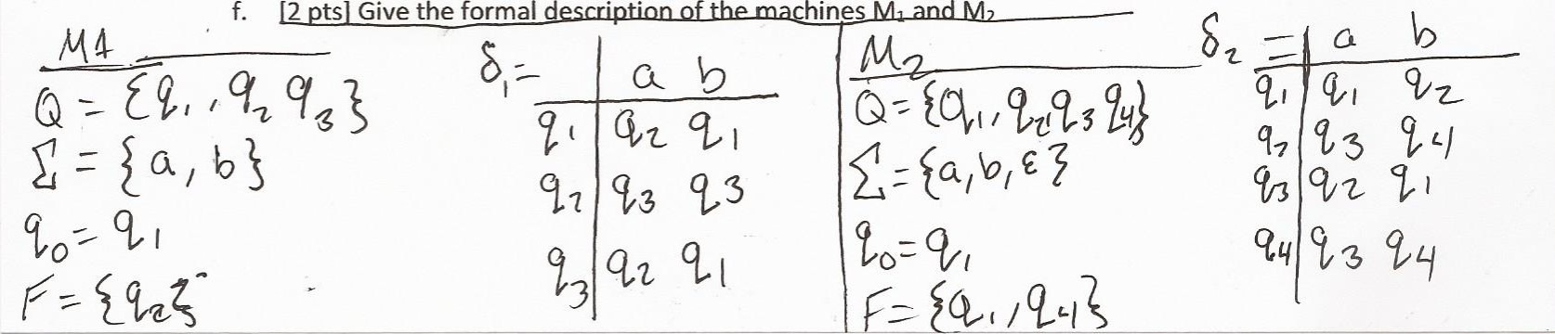

f.

2

d

1. [3 ptsJ'What is the set of accept states?

{q2}

M2-> {qi, q4}

1. [1 pts] Whåt sequence of states does the machine go through on input aabb?

# Ml: q1->q2, q2->q3, q3->q1, ql->ql

M2: qi->ql, qi->ql, qi->q2, q2->q4  d. [1 pts] Does the machine accept the string aabb?

Ml: N6, ql is not an accept state.

M2: Yes, q4 is an accept state.

e. [1 pts] Does the machine accept the string E?

# Ml: No, could not get to accept state from empty string M2: Yes, can get to an accept state from empty string

2. [6 pts] The formal description of a DFA M is ({ql, q2, q3, q4, q5}, {u, d}, B, q3, {q3}), where ö is given by the  following table. Give the state diagram of this machine.

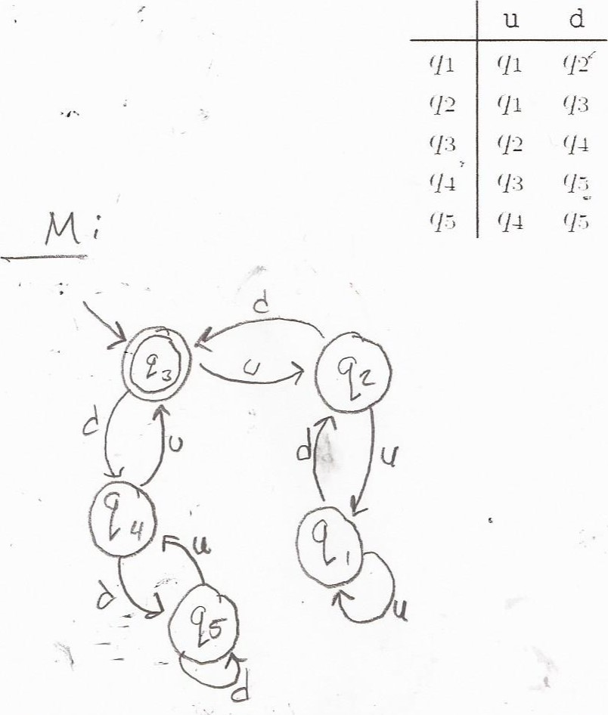

1. [5 pts] Give state diqgrams of DFA recognizing the following language {w I w contains an even number of Os, or

contains exactly two Is}, the alphabet is {O, 1}

000 to

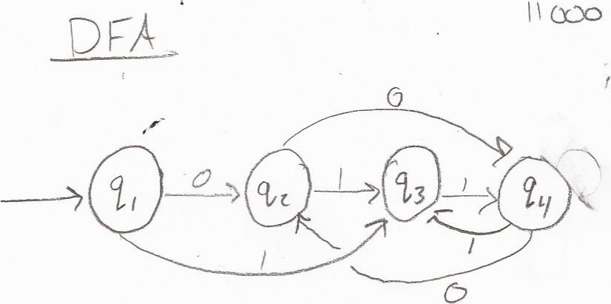l ! 000 